C3 AI Application
Product Design Specification

C3 AI Enterprise Search – CORNEA GURU
Version 1

Date | Version | Author | Reviewer
09.05.23 | v1.0 | Aaron Brown | C3 Internal

Table of Contents
Overview 3
Document Purpose 3
Problem Statement 3
User Story 4
Value 5
5
Project Objectives 5
Use Case Pilot Scope 5
Functional Requirements 6
Data Sources 7
Entity Relationship Diagram 7
Link -> here 7
Solution Architecture 7
Link -> here 7
User Personas, Stories & Adoption Plan 7
User Personas 7
User Stories 8
User Adoption Plan 8
Adoption Champions 9
Measurable KPIs by User Story 9
UX Requirements 11
Information Architecture 11
Searchbar Homepage 12
Search Results – Header 13
Search Results - AI Results 13
Search Results – Documents 17
Application-Specific Configurations 19
AI / ML Approach 19
Project Timeline 21

Overview

Document Purpose
This document specifies the C3 AI Generative AI for Enterprise Search product to be configured as a pilot to CORNEA (USG).
The target audience for this document includes the project leadership team across IT and business, functional subject matter experts (SMEs), and end users (e.g., Report Authors and All Source Analysts).
This document is intended to facilitate understanding of the application functionality and configurations and serve as the source-of-truth for jointly agreed-upon configurations and functional requirements.
This application will be delivered as a base application, with code to model the data built as part of the pilot.

Problem Statement
The United States Government (USG) generates and collects vast amounts of data from various collection platforms. USG members struggle to process raw collection, extract valuable information from it, and share that information with relevant parties because of the overwhelming volume of data, which impedes intelligence production.
Intelligence professionals search through multiple structured and unstructured databases of raw, serialized, and finished intelligence to find insights and build context. Today, this process is manual, time-consuming, and can lead to overwhelming workloads that hinder productivity. Furthermore, significant turnover within individual teams means constant rebuilding of contextual and tradecraft expertise.
To address this challenge, the USG aims to develop, test, and release a Generative Unified Retrieval Utility (GURU). GURU is a digital assistant that will offer natural language-based search and retrieval capabilities for efficiently accessing relevant intelligence information, ultimately assisting intelligence professionals. With GURU, the USIC can achieve significant mission value, including:
- Improved data discovery and access to relevant information
- Increased efficiency and effectiveness of intelligence professionals
- Enhanced collaboration and sharing of information across agencies

User Story
Delivering an Enterprise Search product can vastly improve this process. For example, we could enable USG Analysts to:
- Search across the integrated C3 application, and documents.
- Engage in conversational dialogue to clarify responses.
- Quickly understand what data is available to a particular user across the enterprise.
- Quickly summarize content within unstructured data, such as intelligence reports
- Quickly answer questions for any environmental, equipment or pattern topic.
- Identify discrepancies in separate unstructured data sources.

Value

Project Objectives
- Answer environmental, equipment and pattern questions against unstructured documents.
- Limit search access to specific documents based on user permissions.
- Perform above actions in air-gapped environment.
- Answer questions based on structured flight test data.
- Generate plots & geospatial visualizations using structured flight test data based on user query.

Use Case Pilot Scope
- Achieve necessary security approvals to deploy the C3 AI Platform into the USG development or test environment and process Top Secret (TS) / Sensitive Compartmented Information (SCI) workloads, including TALENT KEYHOLE (TK) and SPECIAL INTELLIGENCE (SI) data.
- Deploy the C3 AI Platform into the Government development or test environment.
- Configure a scalable indexing and embedding pipeline that can accommodate up to hundreds of terabytes of data from up to five (5) data sources.
- Test and evaluate performance of the GURU capability on up to one hundred thousand (100,000) documents or search results limited to one (1) actor focused on five (5) Operational Question topic families.
- Configure one (1) AI retrieval model to organize information extracted from documents.
- Configure one (1) AI large language model to interact with users and the retrieval model.
- Expose results in the C3 Generative AI for Enterprise Search application.
  - Ability to ask questions using natural language.
  - Access AI-generated text answers to user questions, with references.
  - Ranked list of additional relevant search results.
  - Interactive chat interface where a user can ask follow-up questions.
  - Ability for users to provide feedback on search results and AI-generated text responses.

Functional Requirements
- Ability to ask questions using natural language.
- Access AI-generated text answers to user questions, with references
- Ranked list of additional relevant search results.
- Interactive chat interface on the right-hand side where a user can ask follow-up questions.
- Ability for users to provide feedback on search results and AI-generated text responses.
- Shall store anonymized queries for up to 2 years so that teams can see which queries are most commonly made.
- Shall store search history at the user-level for up to 2 years so that prior search history can be surfaced to that user in the UI.
- Shall capture the following metrics on each search:
  - Number of pages in search results accessed per search.
  - Number of search results clicked per search.
  - Length of session (session ends when user initiates a new search, exits search, and accesses a different part of the application, or navigates to a new browser tab)
- Shall have controls in the application layer to ensure that users asking unsupported questions receive standard messaging (prevent overloading Search back-end with unnecessary queries)
- Supported source systems: Internal file stores (Amazon S3, ADLS Azure, Azure Blob, and Google GCS)
- Supported file types for documents: .docx, .doc, .pdf, .txt
  - When crawling the file repository, the following metadata shall be captured and indexed for each document (if available):
    - Topics
    - Keywords
    - Created Date
    - Modified Date
    - Title
    - Author
    - Description
    - File type
  - There shall be a cronjob to re-crawl integrated file repositories.
    - When re-crawling, net-new documents shall be captured and indexed.
    - When re-crawling, any document with a Modified Date that is different from the document’s Modified Date under the previous crawl shall be re-indexed, and the Modified Date shall be re-captured.
    - The cronjob frequency shall be configurable.
    - Default Cronjob Frequency: Daily
- Shall only return query responses and search results with information that users are explicitly granted access to
  - For C3 platform data and application pages, Search shall observe access controls through existing ACL permissions in the underlying application.
  - For documents, Search shall observe access controls when documents are grouped separately by user access group in the file repository.
- Shall have a configuration for all language and retrieval models used in the deployment (so that a new model can be configured without requiring a redeployment of the application)
- Shall support up to 7 external data sources

Data Sources
The datasets listed below are the in-scope date sources relevant to this application.

Type of Data | Description | Access Method | Data Format
Military Equipment and Parametrics Engineering Database (MEPED) | Contains scientific and technical characteristics and assessments (tabular, text, and image data) of foreign weapon systems used to assess equipment capabilities and identify equipment based on electronic emissions. | USG API | JSON
Modernized Integrated Database (MIDB) | Contains foundational military intelligence (tabular, text, and image data) including military capabilities of adversaries and infrastructure in all domains. | USG API | JSON
Data Catalog | Contains USG specific data. | USG API | JSON
Classified Data Source A | Contains tabular- and text-based geolocational data on air-, sea-, and ground-based vehicles. | USG API | JSON
Classified Data Source B | Contains serialized reports of air-, sea-, and ground-based vehicle activity. | USG API | JSON
Classified Data Source C | Contains imagery and associated metadata. | USG API | JSON
Classified Data Source D | Contains serialized imagery reports. | USG API | JSON

Entity Relationship Diagram
The following Entity Relationship Diagram shows the Data Model for the GURU Application.

Link -> here

Solution Architecture
The following architecture shows the solution approach for configuring C3 AI Enterprise Search as GURU.

Link -> here

User Personas, Stories & Adoption Plan

User Personas
User |  | Responsibilities | Pain Points
Report Author | Generate detailed intelligence reports by efficiently analyzing data related to environment, context, patterns, and strategic planning for military operations. |  | Gaining access to needed data can be a long, arduous process; mining insights can also require a lot of time upfront to review document content and structure; historical context is quite useful but often ignored because the user does not know what is available or doesn’t have time to send follow-up requests for those data.
All Source Analyst | Collect, correlate, and synthesize intelligence from diverse sources to create comprehensive reports for informed decision-making in military operations. |  | Navigating through vast volumes of data. Extracting timely insights from diverse sources. Integrating various data types and formats for a comprehensive analysis
Admin User | Monitor usage, add/revoke access to users, monitor query response times, see user history, create credentials, setup connectors, and more |  | Navigating where to find relevant information and make updates, easily find relevant metrics within an application, easily review user feedback, tracking usage at different time intervals, tracking search histories and user actions.

User Stories
As an… | I want to…. | So I can..
Report Author | Efficiently navigate through diverse data sources and analyze information relevant to intelligence report generation, encompassing environmental data, contextual insights, patterns, and strategic planning for military operations. | Produce detailed and comprehensive intelligence reports that offer accurate insights, aid in military planning, and contribute to successful and informed military operations.
All Source Analyst | Uncover pertinent information necessary for comprehensive intelligence reports, supporting ad-hoc analysis, research, and formal/informal reporting within military contexts. | Enhance the depth and precision of my intelligence research, providing valuable insights to contribute to strategic military decisions.
Admin User | Add/remove users from the application and designate level of access, then verify which documents they can access. I also want to update which documents can be accessed by different users. | Ensure no user is capable of retrieving information that should be off-limits based on their user role.

User Adoption Plan

User Adoption Plan

Target number of users = 30 users
Within 2 seconds of a request hitting the capability the generation latency is 10 seconds
Total number of users leveraging specific features
List of Features:
- Primary Search – 30 users
- Results Page – 30 users

Adoption Champions
Persona | Customer Adoption Champion | Total # of Expected Users
All Source Analyst | PACAF & 697th ISR | 20-30
Report Author | CORNEA | 3-5
… | … | …

Measurable KPIs by User Story
Persona | User Story | KPI | Validation Strategy
Report Author / All Source Analyst | Search for content within unstructured data. | - % thumbs up/down  - % queries receiving feedback  - User comment  - Top results clicked.  - Transfers to chat | - Track query and response  - Categorize query type.  - Determine if in/out of scope of corpus of data.  - Review model feedback (comments and thumbs up/down) weekly  - Track clicks  - Track follow-ups in chat
Report Author / All Source Analyst | Follow-up questions in chat | - % thumbs up/down  - % queries receiving feedback  - User comment  - Number of questions in chat  - Time in chat? | - Track query and response  - Categorize query type.  - Determine if in/out of scope of corpus of data.  - Review model feedback (comments and thumbs up/down) weekly
Report Author / All Source Analyst | Search for data visualization. (future phase) | - % thumbs up/down  - % queries receiving feedback  - User comment | - Track query and response  - Categorize query type  - Determine if in/out of scope of corpus of data  - Review model feedback (comments and thumbs up/down) weekly  - Track clicks
Report Author / All Source Analyst | Search that retrieves a visual directly from an application. (future phase) | - Click-throughs to the application (conversion rate)  - Uptick in application page views | - Track query and response  - Categorize query type  - Determine if in/out of scope of corpus of data  - Track clicks to application pages  - Track application page views
Overall | Tracking usage | - Queries/user  - Daily active users  - Return users  - Time spent on the app  - Number of follow-ups in chat | - Extract user logs weekly  - Monitor usage across all roles
Overall | Tracking user sentiment | - Survey responses | - Send surveys monthly

UX Requirements

Information Architecture
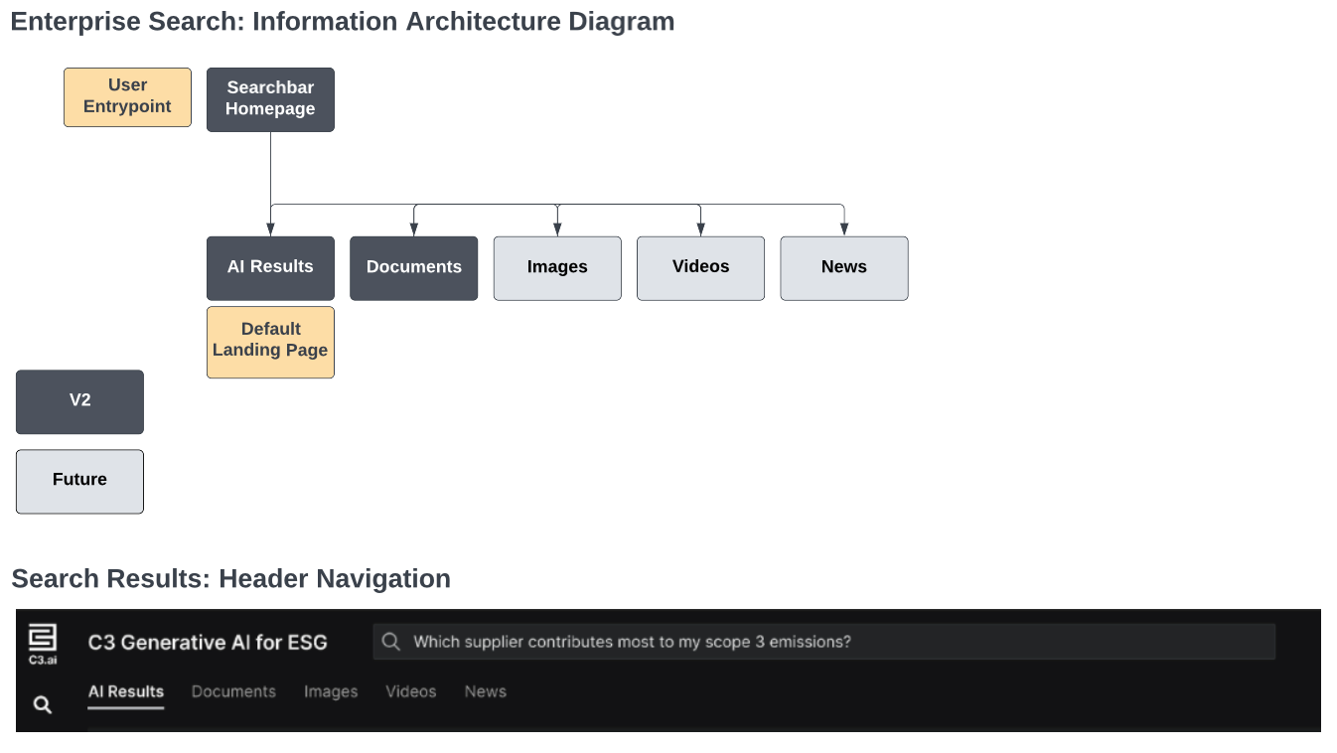

Component | Requirements | Content
Search Icon | - When a user selects the Search icon in the left-hand application panel, they shall be redirected to their last Search Results from their current application session, including their last accessed tab (e.g. AI Results, or Documents).  - If the user has not yet generated a search in their application session, they shall land on the Searchbar Homepage. | N/A
Settings Icon | - When an admin selects the Settings icon in the left-hand application panel, they shall see a self-service source configuration flow. | N/A

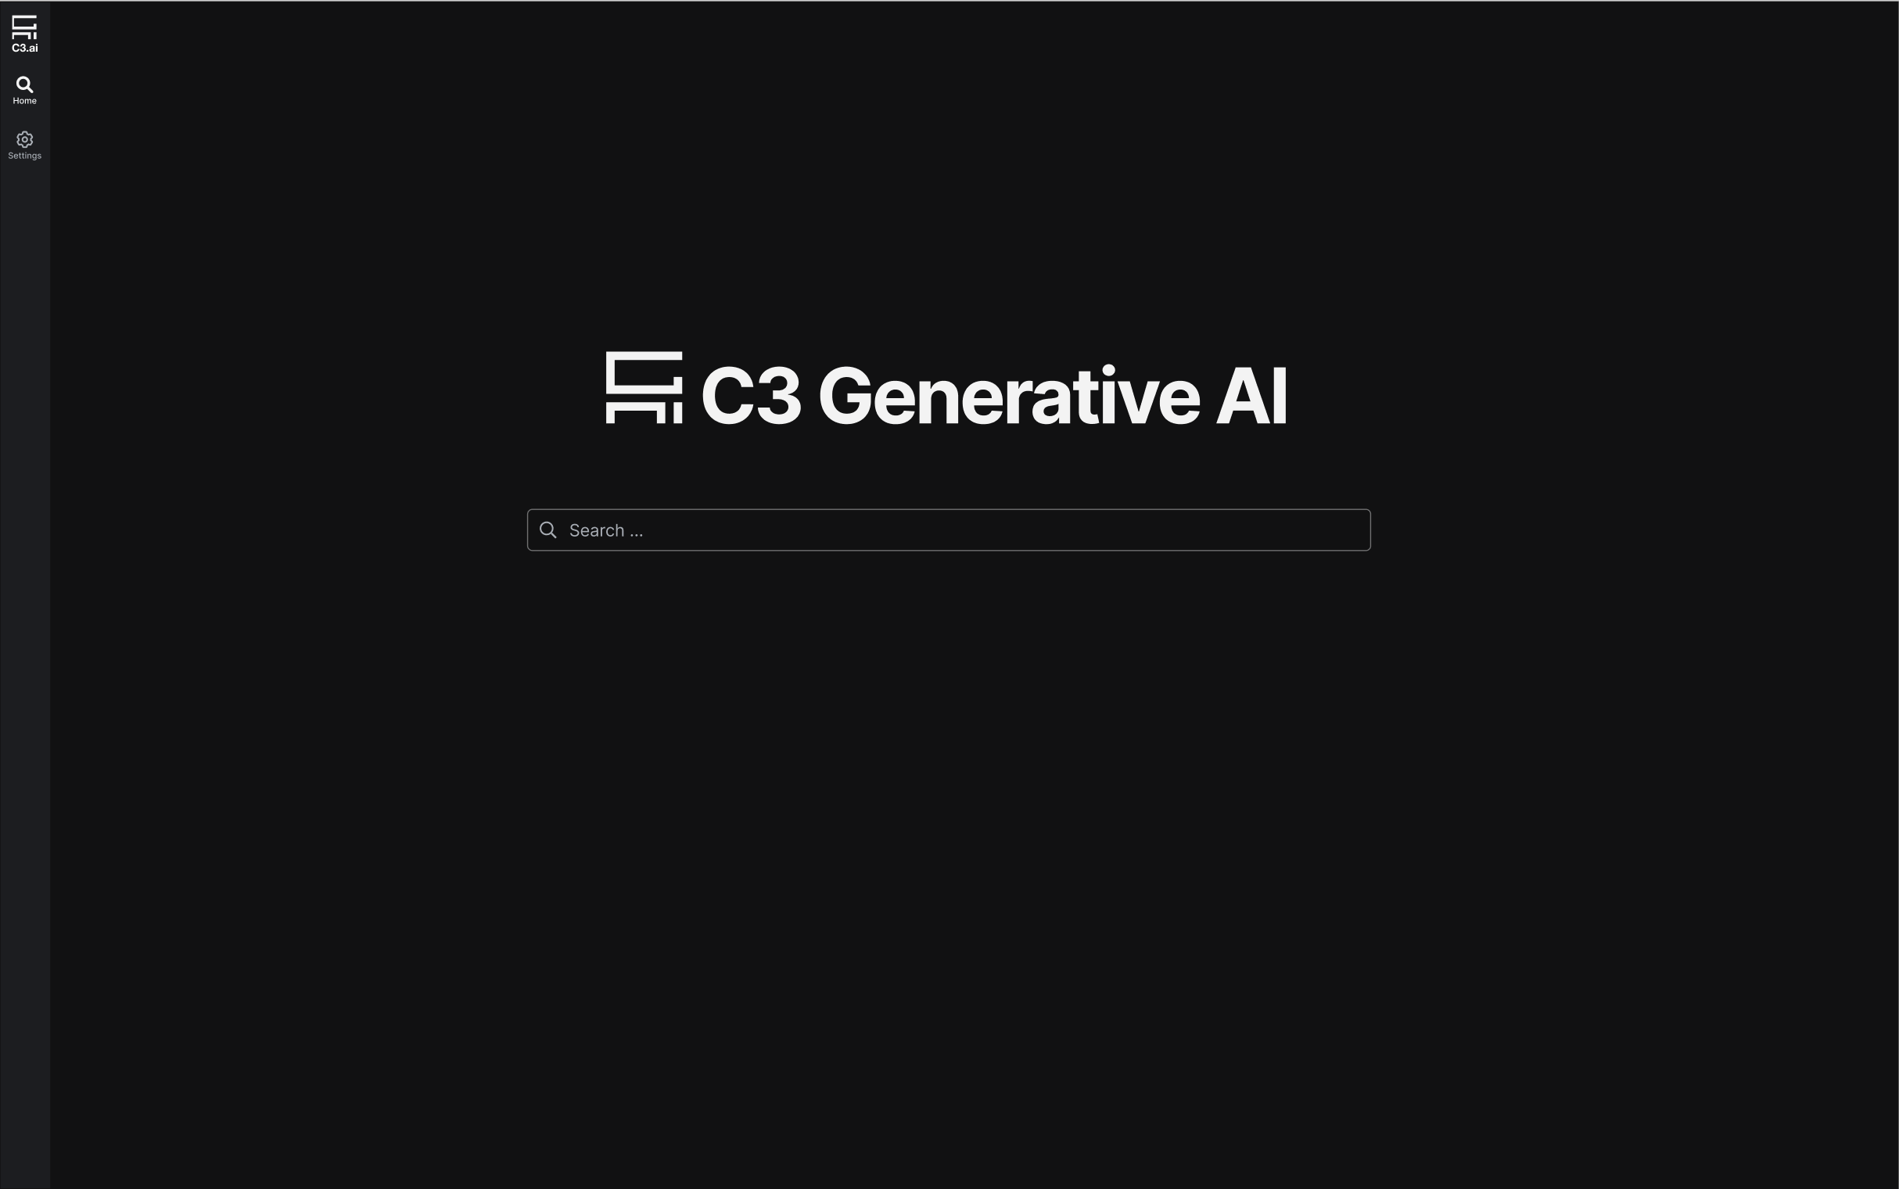
Searchbar Homepage

Component | Requirements | Content
Classification Banner | Display the highest level of classification of the content displayed to the user. For unclassified demonstration purposes display as green banner with text of “UNCLASSIFIED” | N/A
C3 Generative AI Banner |  | N/A
Search-bar | - Search-bar shall load in an empty state with user cursor automatically in the Search Bar (e.g. user should be able to immediately start typing their query after navigating to this page).  - If user clicks into search bar, up to five suggested search queries shall display. Suggested search queries shall include: queries relevant to their most recent prior searches, and their prior search queries (in that order).  - Once the user starts typing their query, the suggested search queries shall refresh after a 0.5 second debouncing time. The suggested search queries shall contain an exact match in the start of string for the user’s query.  - If the suggested search query includes words that were not explicitly provided by the user, those words shall be bolded.  - If the user clicks on a suggested search query, that query shall be populated into the Search-bar.  - If the user uses the up and down arrows to navigate suggested search queries, the query currently in focus for the user shall be populated into the Search-bar.  - When the user presses enter, the search shall be executed, redirecting the user to the Search Results - AI results tab. | Ghost text: Search Icon  Ghost text (initial): Search  Ghost text (after user input): <content of user query>

Search Results – Header

Component | Requirements | Content
Global Search-bar | - Search-bar shall load containing the user’s query.  - If user clicks into search bar, up to five suggested search queries shall display. Suggested search queries shall include: queries relevant to their most recent prior searches, and their prior search queries (in that order).  - Once the user starts typing their query, the suggested search queries shall refresh after a 0.5 second debouncing time. The suggested search queries shall contain an exact match in the start of string for the user’s query.  - If the suggested search query includes words that were not explicitly provided by the user, those words shall be bolded.  - If the user clicks on a suggested search query, that query shall be populated into the Search-bar.  - If the user uses the up and down arrows to navigate suggested search queries, the query currently in focus for the user shall be populated into the Search-bar.  - When the user presses enter, the search shall be executed, refreshing the tab they are currently on (e.g. AI Results tab, Documents tab) with updated results.  - When a user has generated a search and navigates to a new tab after receiving their initial search results, their search query shall be stored on the UI, and the query shall run on the new tab. | Ghost text: Search Icon  Ghost text (initial): Search  Ghost text (after user input): <content of user query>

Search Results - AI Results
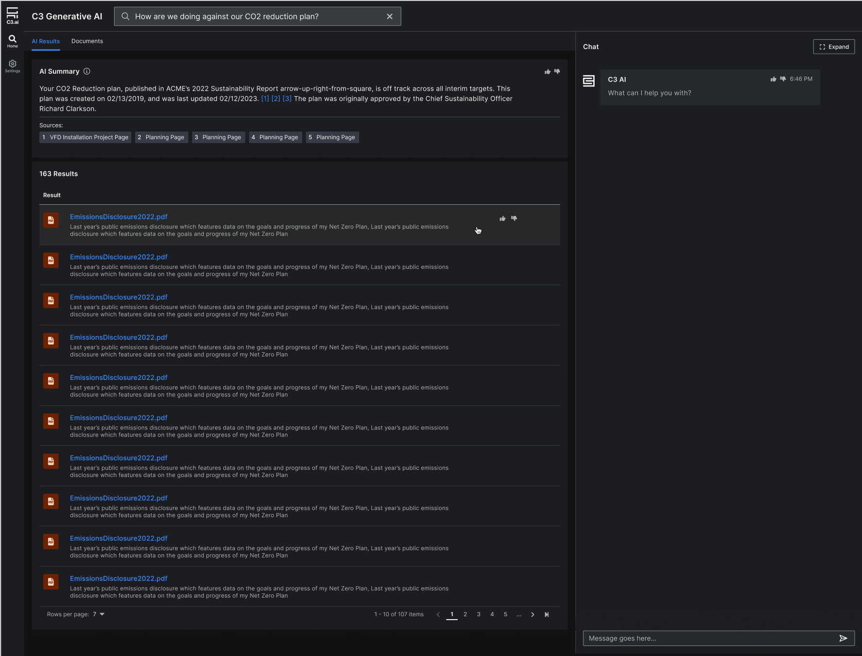

Component | Requirements | Content
Classification Banner | Display the highest level of classification of the content displayed to the user. For unclassified demonstration purposes display as green banner with text of “UNCLASSIFIED” | N/A
AI Summary Container | - The AI summary text shall be dynamically generated by the language model.  - The AI summary shall answer the question at hand.  - If the AI summary cannot answer the question at hand due to lack of relevant information, it shall respond with a generic error message - “There is not enough information to answer your question. Please try searching something else.”  - A C3 AI response shall have in-line source references (i.e. [1]) embedded into the response, with hyperlinks appended below the response. (i.e. 1. iSpy link).  - If the user selects the ‘thumbs up’ feedback mechanism, the user thumbs-up shall be stored with the C3 response as metadata, noting that the response was relevant.  - After selecting ‘thumbs up’, a modal shall display prompting the user to provide more feedback.  - Selecting X shall close the modal.  - Selecting Cancel shall close the modal.  - The ‘Submit’ button shall default to inactive until the user has either selected a multi-select reason code, or provided text entry in the comment box.  - Selecting ‘Submit’ shall submit user feedback.  - If the user selects the ‘thumbs down’ feedback mechanism, the user thumbs-down shall be stored with the C3 response as metadata, noting that the response was not relevant.  - After selecting ‘thumbs down’, a modal shall display prompting the user to provide more feedback.  - Selecting X shall close the modal.  - Selecting Cancel shall close the modal.  - The ‘Submit’ button shall default to inactive until the user has either selected a multi-select reason code, or provided text entry in the comment box.  - Selecting ‘Submit’ shall submit user feedback. | Card Header: AI Summary  Card Header: <Information Icon>  - Tooltip text: The AI Summary shares key insights from your top search results.  Content Header: <dynamic>  - Shall support text only in V2 (no styling)
AI Summary Data Visualization | - The data visualization shall be dynamically generated.  - If no data visualization can be generated for the query at hand, the data visualization component shall be suppressed. | <Dynamically Generated Data Visualization or Grid>
Search Results Grid | - Search results shall be default sorted by relevance score, which shall be based on embedding similarity.  - The hyperlinked artifact shall render as a maximum of one line upon page load, trailing off in an ellipses if the artifact is longer than one line.  - When a user selects a hyperlinked artifact from a search result that is a .pdf file, a new tab shall open with the relevant artifact, redirecting the user to the new tab.  - When a user selects a hyperlinked artifact from a search result that is not a C3 application page or a .pdf file, the relevant artifact should automatically download to the user’s device through the native browser download capability.  - When a user hovers over a row, in-line thumbs-up and thumbs-down icons shall appear.  - When a user selects the ‘thumbs up’ feedback mechanism, the user thumbs-up shall be stored with the C3 response as metadata, noting that the response was relevant.  - When a user selects the ‘thumbs down’ feedback mechanism, the user thumbs-down shall be stored with the C3 response as metadata, noting that the response was not relevant.  - The avatar image corresponding to an application search result shall be pre-configured and mapped by Source.  - The description of the search result shall be a pre-chunked passage that renders as a maximum of two lines upon page load, trailing off in an ellipses if the pre-chunked passage is longer than two lines.  - If no search results are returned, the grid should load in an empty state. The grid shall display the following message:  - Header: No Relevant Results  - Body: There is not enough information to answer your question. Please try searching something else.  - A maximum of 1000 search results shall be supported.  - The Search Results grid shall display up to ten rows upon default. | Header: <count of total results> results  Column 1: Results  - Logo: <dynamic svg>  - Row Header: <Application Page Name/Document Name>  - Sub-content: <first two lines of pre-chunked passage parsed from artifact>  Column 2: Sources  - <Source of Information>  - C3 AI  Column 3: Types  - <Name of Source Type>  - Application  - Capitalized file extension  - Example: DOCX  - Example: CSV  - Example: PDF

Search Results – Documents
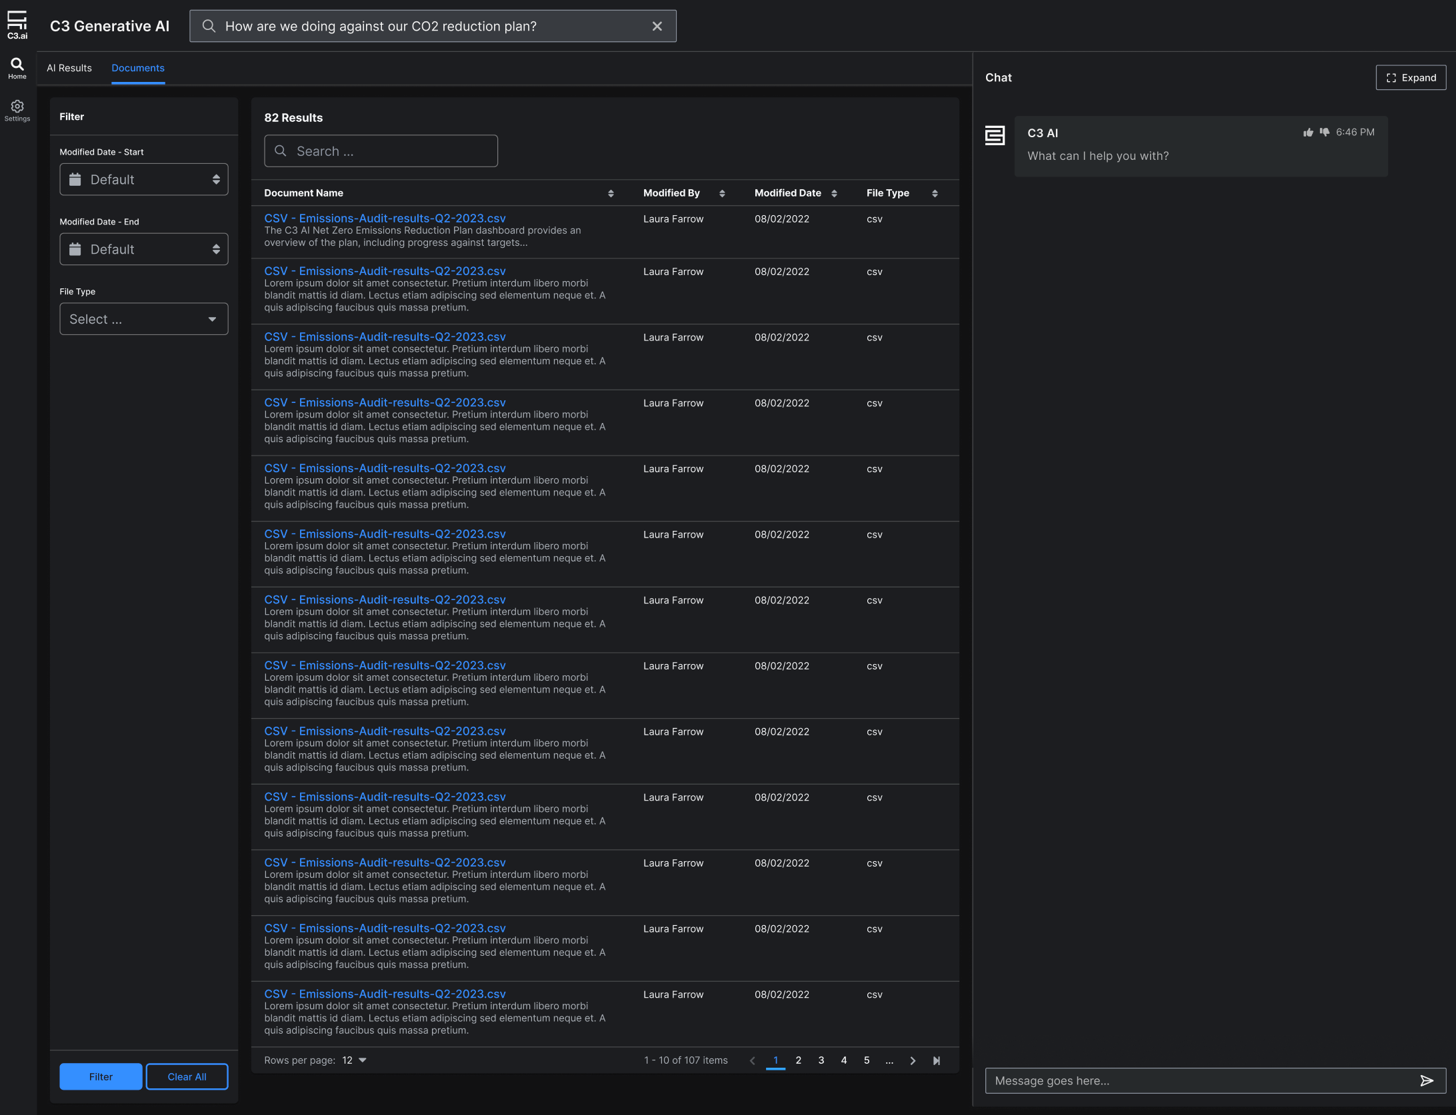
Component | Requirements | Content
Filter Panel | - Filters shall be configurable, so that an integrating application can customize filters if desired.  - Default filters shall be:  - Modified Date - Start  - Modified Date - End  - File Type  - Additional filters shall be:  - Created Date - Start  - Created Date - End  - Author | Header: Filter  Filter 1: Modified Date - Start  Filter 2: Modified Date - End  Filter 3: File Type
Search Results Grid | - Search results shall be default sorted by relevance score, which shall be based on embedding similarity.  - The hyperlinked artifact shall render as a maximum of one line upon page load, trailing off in an ellipses if the artifact is longer than one line.  - When a user selects a hyperlinked artifact from a search result, a new tab shall open with the relevant artifact, redirecting the user to the new tab.  - When a user selects the ‘thumbs up’ feedback mechanism, the user thumbs-up shall be stored with the C3 response as metadata, noting that the response was relevant.  - When a user selects the ‘thumbs down’ feedback mechanism, the user thumbs-down shall be stored with the C3 response as metadata, noting that the response was not relevant.  - Default columns shall be:  - Document Name  - Modified By  - Modified Date  - File Type  - Additional columns shall be:  - Created Date  - Source  - The description of the search result shall be a pre-chunked passage that renders as a maximum of two lines upon page load, trailing off in an ellipses if the pre-chunked passage is longer than two lines.  - If no search results are returned, the grid should load in an empty state. The grid shall display the following message:  - Header: No Relevant Results  - Body: There is not enough information to answer your question. Please try searching something else.  - A maximum of 1000 search results shall be supported.  - The Search Results grid shall display up to ten rows upon default. | Header: <count of total results> results  Column 1: Document Name  - Row Header: <Document Name>  - Sub-content: <first two lines of pre-chunked passage parsed from artifact>  Column 2: Modified By  - <Document Author, if exists in Document Metadata>  Column 3: Modified Date  - <Date Artifact was Last Updated>  - For an externally published artifact, this most likely will be the created date (unless the publisher also has appended a ‘last modified’ or ‘last updated’ date).  - For an internal artifact, this will correspond to the date the artifact was last updated.  Column 4: File Type  - Capitalized file extension  - Example: DOCX  - Example: CSV  - Example: PDF
Chat Side-panel | - Chat side-panel behavior shall be identical to that of the AI Results tab.

Application-Specific Configurations
- Role-based Access Controls
  - C3 Application: Leverage ACL platform capability
  - Documents: Documents will be grouped separately by user access group in the file repository. For each user access group, the application will need to configure the root file location, and User Group Name. For each user group, the application will need to specify a list of User IDs that belong to each User Group.
- File Crawling Cronjob Frequency
  - Applications will need to identify how frequently they want to crawl and index incremental additions to their integrated file repositories.
  - Default frequency: daily
- Language & Retrieval Models Used
  - Applications will need to configure language & retrieval models used in their deployment. This shall allow them to swap out underlying models without having to redeploy the Search application.
- C3 AI Chat: Welcome Message
  - Default text: What can I help you with?

AI / ML Approach
C3 Generative AI for Enterprise Search provides USG stakeholders with a transformative user experience using a natural language interface to rapidly locate, retrieve, and present all relevant data across the entire corpus of an enterprise’s information systems. Using deep learning and generative AI models, C3 Generative AI for Enterprise Search understands natural language queries constructed by human users and helps users find and retrieve relevant answers rapidly.
AI/ML Goal | AI/ML Models
Capture relevant information from documents and other sources. | Retrieval Models: These algorithms or frameworks are part of the product’s information retrieval system that ranks and retrieves relevant information in response to user queries. The models aim to determine the relevance of data in the larger corpus and provides a ranked list of results. There are various retrieval models that can be configured to function within the C3 Generative AI for Enterprise Search product.  Examples: ColBERT and ELSER
Support understanding of user’s context and intent, as well as generate responses that summarize results. | LLMs: These transformer-based language models are considered examples of Generative AI models. These models support better understanding of questions that are asked, so that they can be decomposed and answered in precise language from context. The Enterprise Search product can leverage LLMs for different purposes and within different frameworks across the toolchain in order to properly answer a wide variety of questions.  Examples: FLAN-T5, MPT, Falcon
GURU combines and orchestrates generative AI transformers with the C3 AI Platform and Applications, as well as other enterprise applications and data. Retrieval models will embed the user’s query into a high-dimensional vector and find the closest match(es) in a corpus of data for end-to-end retrieval. LLMs, such as Falcon-40B, will provide synthesis and summary against the retrieved data to present the most relevant, concise information rapidly.
Limitations & Bias
The following factors may degrade system performance and bias results:
Inappropriate Material
If there is data ingested that is harmful in nature or deemed inappropriate, the system may reveal that information within search results or summary responses. Human feedback mechanisms are built into the application to allow users to alert administrators if any content returned is harmful or inappropriate so that such material can be removed from the corpus of data.
Related DoD Responsible AI Tenants: RAI Governance, Responsible AI Ecosystem
Inaccurate Information
The system is designed to return information that resides within the enterprise corpus of data. It is up to the user to vet the information returned, as the models cannot determine whether the information returned is factual or constitutes disinformation. The application offers full traceability to the sources of information, allowing users to determine whether sources are credible or accurate. Administrators will have the ability to remove documents within the corpus or identify the location of data at its source, to take corrective action, if needed.
Related DoD Responsible AI Tenants: RAI Governance, Responsible AI Ecosystem, Warfighter Trust, Responsible AI Ecosystem, AI Workforce
Bias in LLMs
LLMs are trained a wide array of datasets that can lead to inherent biases that can reinforce stereotypes across different demographics or sub-populations. The C3 framework for QA counteracts these biases and ensures responses are grounded in retrieved texts and nothing else. Beyond that, C3 tracks metrics on bias, toxicity, and fairness to monitor for these behaviors. If systematic issues become apparent, C3 implements RL-based fine-tuning approaches to restrict that.
Related DoD Responsible AI Tenants: RAI Governance, Responsible AI Ecosystem, Warfighter Trust, Responsible AI Ecosystem

Project Timeline

